**Documentation of Learning Center for Odoo 7.0**

**Usage:** Tutorial for Employee

**Technical Name:** ix_manual_pages

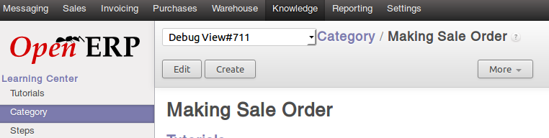

1. **User Interface**
   1. **Menu**

Access Learning Center by select Knowledge menu.

* 1. **Tutorial**

Click Tutorial menu and you will see list of tutorials that has benn created.

* 1. **Category**

This menu will show you categories of Tutorial.

* 1. **Steps**

Contain steps of tutorials.

1. **Creating Tutorial**
   1. Before you create a tutorial, you are suggested to create its steps first.
   2. Click on **Steps** menu and create some steps.
   3. Link those steps each other using **Previous** and **Next** fields. Steps is a sequences. The first step is the step with **Previous** field unfilled.
   4. Click **Tutorial** and fill **Start Tutotial** field with the first step you’ve been created.
2. **Creating Category**
   1. Click **Category** menu and create a category.
   2. You could assign category through Tutorial page by assign tutorial’s **Category** field.